St. Joseph Radio
Application for
Catholic Woman of the Year 2026
Heart of the Church
Archdiocese of St. Louis, MO
Please submit nomination application by August 7, 2026. Do not hesitate to call 636-447-6000 if you have questions.  Parishes may nominate one or more women from various organizations: Knights of Columbus Women’s Auxiliary, St. Vincent DePaul, Legion of Mary, Pro-life group, etc. Individuals may nominate, also.  Candidates must be practicing Catholic laywomen in the Archdiocese of St. Louis who, as unpaid volunteers, contribute outstanding service to the Church and community in the humble, quiet spirit of Our Lady. An individual may be nominated every other year. | 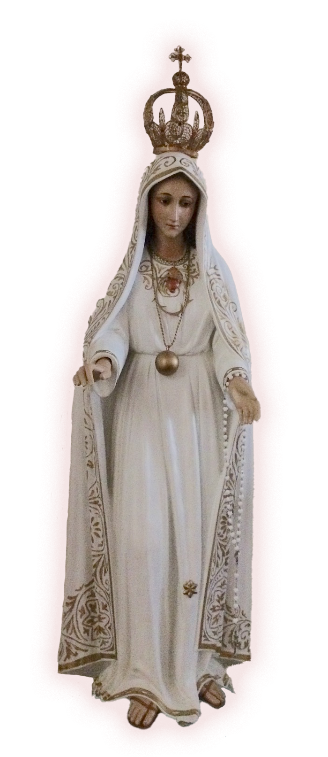
Please fill out the following application form and email the completed application form to womanoftheyearstl@saintjosephradio.net or mail to:

St. Joseph Radio
3827 McClay Road
St. Peters, MO 63376

Along with your application, please include a digital photo (jpeg format).
Forms may also be downloaded at www.saintjosephradio.net

The CWOY award dinner will be held on September 13, 2026.
A dinner reservation form is included as the last page of this nomination package.

The inspiration offered by the women nominated for “Catholic Woman of the Year” is truly a gift to all of us. We can only imagine the number of lives that have been touched through their generosity and faith filled contributions of time and talent for Almighty God and His Church.
Catholic Woman of the Year 2026
Dear Sponsor,
The Catholic identity of a woman being nominated for the Saint Joseph Radio Catholic Woman of the Year (CWOY) is critical to the honor. Therefore, the Archdiocese of St. Louis has requested that we receive assurance of her good standing with the Church, both on a personal level and a public level. This is to be done by answering the questions, below. The nominee’s pastor’s signature on this form will confirm her Catholic identity.
Thank you in advance for your assistance with this aspect of the nomination process.
Sincerely in Christ,
Lu Cortese,
Executive Director St. Joseph Radio
Sponsor completes the brief questionnaire, below, and the first page of the application prior to Pastor’s approval.
1. How long have you (sponsor) known this nominee? ____________________________________
2. Does she adhere to the faith and moral teachings of the Catholic Church? ____________
3. If married, is her marriage valid according to the Church? ______________________________
4. Additional Comments (optional): _____________________________________________________________________________________________________
_____________________________________________________________________________________________________
Sponsor’s Signature:_________________________________________________ Date:________________________
Pastor’s Signature: ___________________________________________________ Date:________________________

Catholic Woman of the Year Application
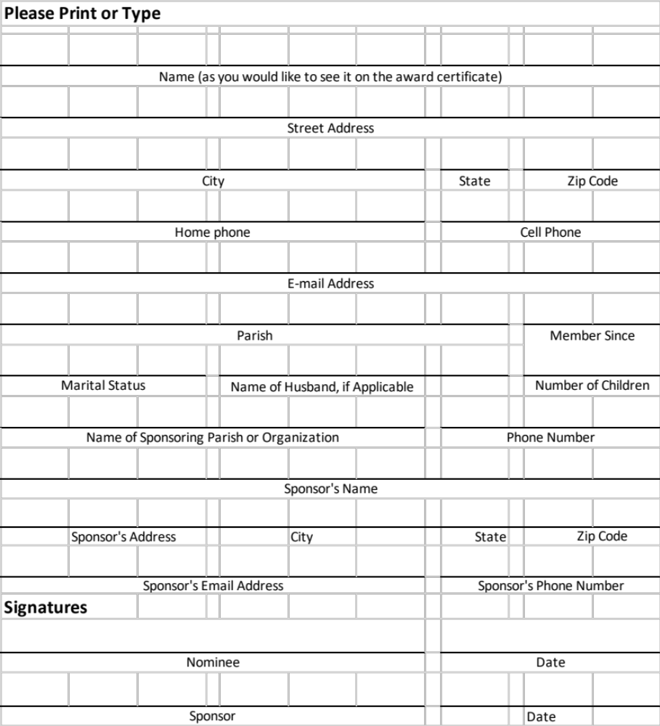

(Please provide responses on separate pages)
To be completed by nominee:
1. Current services (Include names of organizations, clubs, activities, ministries, etc. and who benefit by your service, e.g., helping children, homeless, sick, etc.):
1.1 Identify your current service record and activities for church, community, family, etc.
1.2 List significant activities of the past five (5) years.
2. Service history beyond the past five (5) years (Include names of organizations, clubs, activities, ministries, etc. and who was affected by your service, e.g. helping children, homeless, sick, etc.):
2.1 Past activities, Church/Community/Faith
2.2 List significant activities of your life experiences.
3. General questions (We suggest filling out this part with your sponsor in an interview format. Tell us your story):
3.1 Tell us what drives you to volunteer for God.
3.2 Who and/or what helped to form your moral and spiritual outlook on life?
3.3 Who and/or what motivates you to do the work that you do and to be in service?
3.4 What do you think is the most important way to pass on the faith to lives that you touch?
3.5 How do you see yourself as being a Heart of the Church?
To be filled out by Sponsor
Provide the reasons why you are nominating this woman, including her unique qualities that make her a good Catholic Woman of the Year candidate. Include any additional church, family, and personal information that would help the judges understand the qualities and virtues of your nominee – characteristics that exemplify those of Our Lady: holy, humble, just, defender of the faith, faithful to God’s will, etc. These inputs can be very helpful for our judges to learn about your nominee.
Dinner Reservations for Catholic Woman of the Year 2026
Hilton St. Louis Frontenac – 1335 South Lindbergh Blvd. – St. Louis, MO 63131
Join us Sunday September 13, 2026, 4-8 P.M., for the dinner honoring our Catholic Woman of the Year. Nominees. Please include family, friends, sponsor and others from your church and personal community for this wonderful, inspiring evening.
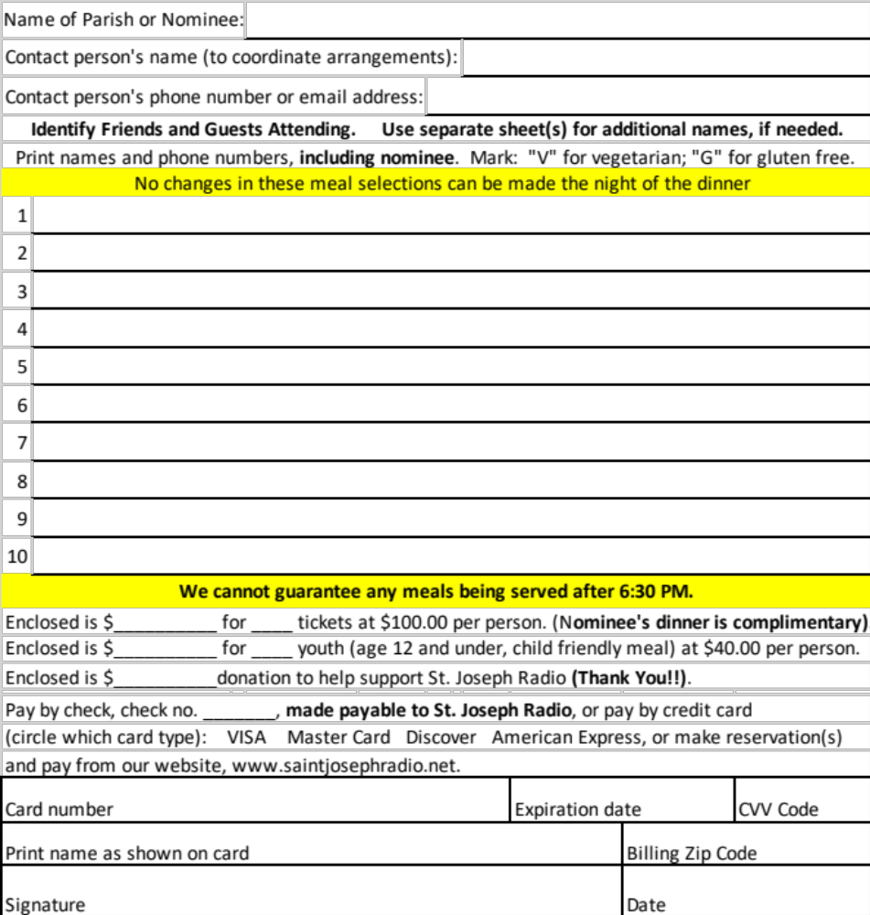
Do not email credit card information.
Dinner reservations with payment are due no later than September 5, 2026.
Mail this form with payment to:
St. Joseph Radio – 3827 McClay Road - St. Peters, MO 63376.
For additional information, please visit www.saintjosephradio.net or call 636-447-6000.
tt

