Catholic Man of the Year 2026
Sponsored by
SJEN-St. Joseph Catholic Radio
Diocese of Orange, CA
Cursillo of Orange County

Please submit the Catholic Man of the Year (CMOY) application
by October 30, 2026.

Do not hesitate to call 636-447-6000 if you have any questions.  Parishes may nominate one or more men from various organizations: Knights of Columbus, Legion of Mary, St. Vincent DePaul, etc. Individuals may also submit nominations.  Candidates must be practicing Catholics in the Diocese of Orange, CA who, as unpaid volunteers, contribute outstanding service to the Church and community in the humble, quiet spirit of St. Joseph. An individual may be nominated every other year. | 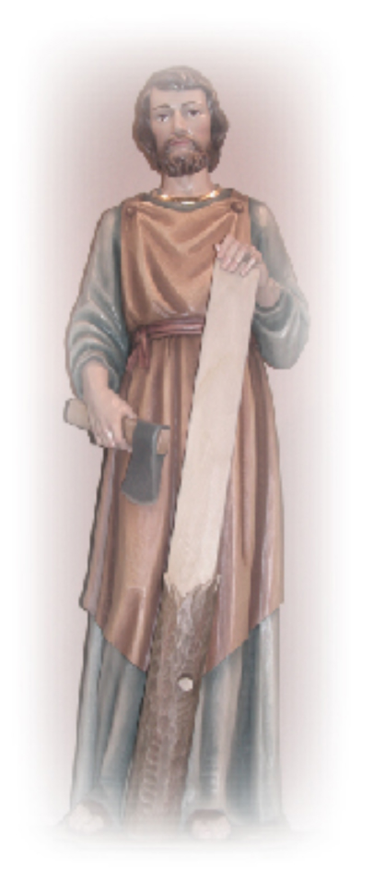
Please fill out the following application form and email the completed application form to manoftheyearSTL@saintjosephradio.net or mail to:
Susan Gutierrez 7962 Poinsettia Dr. Buena Park, CA 90620.
Along with your application, please include a photo (print or jpeg format if emailed).
Forms may also be downloaded at: www.saintjosephradio.net
The CMOY award dinner will be held on December 6, 2026.
A dinner reservation form is included as the last page of this nomination package and may be submitted separately from the application.

The inspiration offered by those nominated for “Catholic Man of the Year” is truly a gift to all of us. We can only imagine the number of lives that have been touched through their generosity and faith filled contributions of time and talent for Almighty God and His Church.
Catholic Man of the Year 2026

Dear Sponsor,

The Catholic identity of a man being nominated for the SJEN-Saint Joseph Radio Catholic Man of the Year (CMOY) is critical to the honor. Therefore, we require assurance of his good standing with the Church, both on a personal level and a public level. This is to be done by answering the questions, below. The nominee’s pastor’s signature on this form will confirm his Catholic identity.
Thank you in advance for your assistance with this aspect of the nomination process.
Sincerely in Christ,
Lu Cortese,
Executive Director
SJEN-St. Joseph Radio
Sponsor completes the brief questionnaire, below, and the first page of the application prior to Pastor’s approval.
1. How long have you known this nominee? _______________________________________________
2. Does he adhere to the faith and moral teachings of the Catholic Church?____________
3. If married, is his marriage valid according to the Church? ______________________________
4. Do you know any reason why this nominee would not represent a good example of a “Catholic Man of the Year” (only check “yes” or “no” to respect privacy): O-yes or O-no.
5. Additional Comments (optional): ____________________________________________________________________________________________________
____________________________________________________________________________________________________
Sponsor’s Signature: ___________________________________________________Date: _________________
Pastor’s Signature: ________________________________________________________Date: _________________

Catholic Man of the Year Application

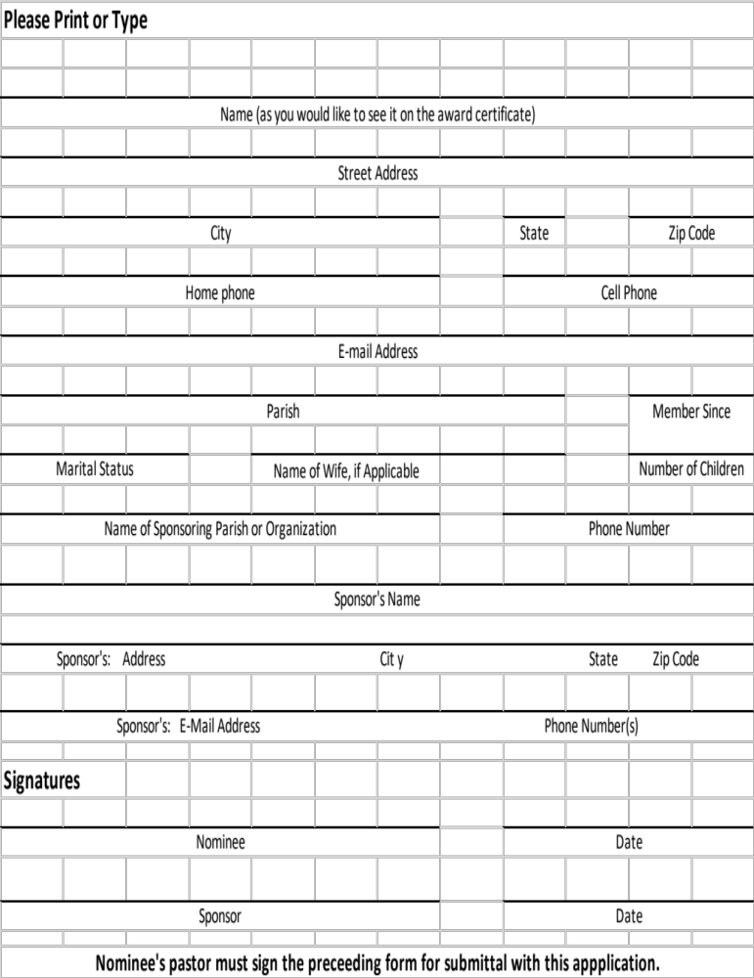
Diocese of Orange, CA

(Please provide responses on separate sheets)
To Be Completed By Nominee:
1. Current Services: Include names of organizations, clubs, activities, ministries, etc. and who is affected by your service, such as children, homeless, sick, etc.
1.1 Identify your current service record and activities for church, community, family, etc.
1.2 List significant activities of the past five (5) years.
2. Service History prior to the past five (5) years: Include names of organizations, clubs, activities, ministries, etc. and who was affected by your service, e.g., helping children, homeless, sick, etc.
2.1 Past activities, Church/Community/Faith
2.2 List significant activities of your life experiences.
3. General Questions--Tell us your story. We suggest filling out this part with your sponsor in an interview format.
3.1 Tell us what drives you to volunteer for God..
3.2 What and/or who helped to form your moral and spiritual outlook on life?
3.3 What and/or who motivates you to do the work that you do and to be in service?
3.4 What do you think is the most important way to pass on the faith to future generations?
To be filled out by Sponsor
Provide the reasons why you are nominating this man, including his unique qualities that make him a good Catholic Man of the Year candidate. Include any additional church, family, and personal information that would help the judges understand the qualities and virtues of your nominee – characteristics that exemplify those of St. Joseph: hard worker, protector, holy, just, defender of the faith, etc. These inputs can be very helpful for our judges to learn about your nominee.

Please email a photograph or headshot of nominee with the competed application.

Location of the award dinner will be:
Majestic Garden Hotel 900 S. Disneyland Dr. Anaheim, CA 92802
(Entrance on Ball Road)
Join us Sunday December 6, 2026, 4:30-8:00 P.M., for the dinner honoring our Catholic Men of the Year nominees. Please include family, friends, sponsor and others from your church and personal community for this wonderful, inspiring evening.
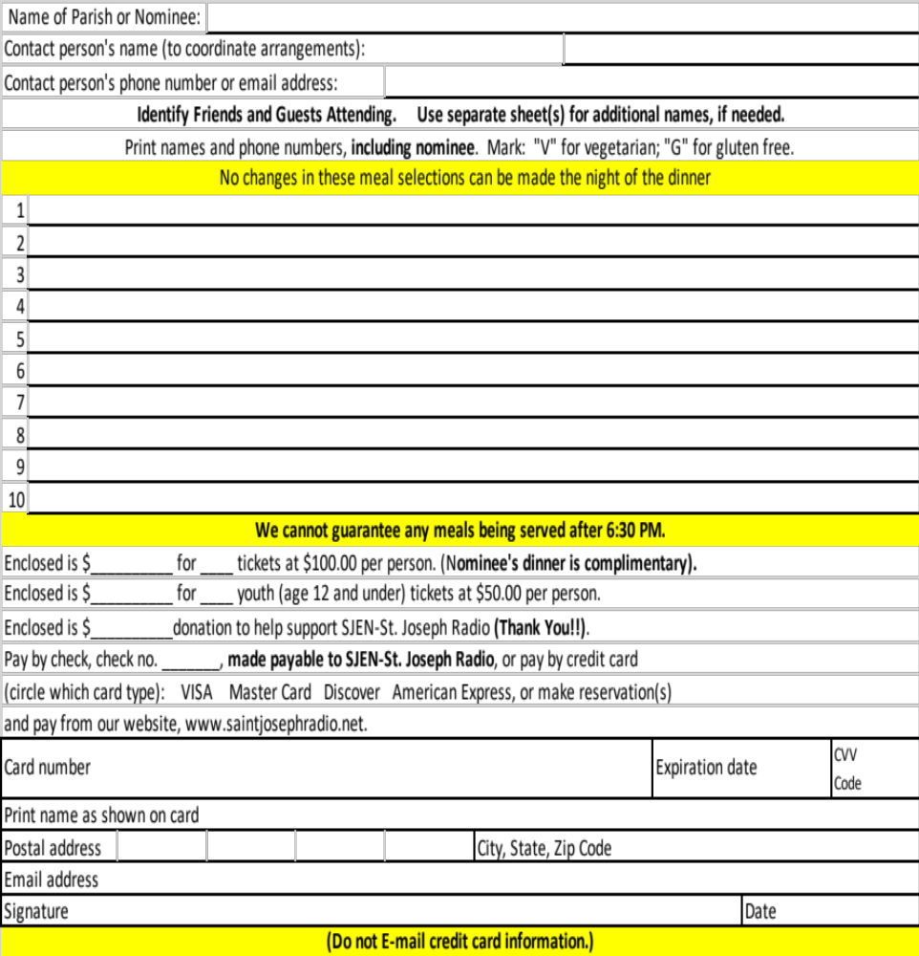
Please submit the completed Nominee Application no later than October 30, 2026 and this Dinner Reservation form and payment no later than November 25, 2026 to:
Susan Gutierrez 7962 Poinsettia Dr. Buena Park, CA 90620
For additional information, please visit www.saintjosephradio.net or call 636-447-6000.

